Interpretation on the boxplot for its skewness
After reviewing your `FishPar` function, I can see that the skew in the boxplot’s median line might be related to either the data or how the bootstrap resampling is implemented. Here’s a breakdown of potential causes and some suggestions to help ensure that the model's outputs are scientifically sound and properly visualized:

Bootstrap Resampling Process
The bootstrap resampling appears correct in the sense that you’re resampling the data and calculating `Lmax` and derived parameters each time. However, if the original data distribution is highly skewed, this could be causing the resampled median values to lean towards one end consistently, showing up in the boxplot. This skew could indicate that the median might not be an ideal central measure for some of these resampled data distributions.
Suggestion: Check the distribution of `Lmax` and other parameters within `parameter_estimates`. If they are heavily skewed, consider using a transformation on the data or reporting other measures like the trimmed mean or median of bootstrap samples, rather than relying on a single central tendency measure.

Confidence Intervals
You calculate the confidence intervals using the 2.5th and 97.5th percentiles for each parameter estimate. This is generally fine, but keep in mind that if the distributions of these parameters are skewed, the confidence intervals might also be skewed or not centered around the mean.
Suggestion: You might consider adding a skewness measure to each parameter distribution and examining whether certain parameters show a high skew. If they do, interpreting the confidence intervals as symmetric around the mean could be misleading.

Boxplot Visualization
The skew in the median line in the boxplot (closer to the top or bottom) is common when data has an asymmetric distribution. In scientific reporting, this isn’t inherently an issue as long as you’re aware of the skew and explain it where relevant.
Solution: It would help to add a note about the skew in your documentation. If the skew is not problematic for interpretation, you can leave the visualization as is. If it is, consider using alternative visualization techniques like violin plots or density plots alongside the boxplot to better capture and represent the distribution shape.

Modeling and Scientific Validity
Scientific Validity: The parameters and calculations you’re using (e.g., `Linf`, `Lmat`, `Lopt`) follow standard approaches in fisheries stock assessment and length-based indicators. As long as the data input and assumptions about these parameter relationships (e.g., the ratios between `Lmat`, `Lopt`, etc.) are scientifically sound, the function should be valid.
Model Sensitivity to Data Distribution: If the model is sensitive to the data distribution and if your specific use case involves a skewed distribution, consider testing the model on multiple datasets with different characteristics to confirm robustness.

Further Debugging Tips
Density and Histogram Inspection: In the section where you plot density and histograms of each parameter (e.g., `Lmax`, `Linf`), carefully inspect these plots to see if they indicate significant skewness. This will give insights into why the boxplot median might be leaning towards one side.
Alternative Summary Statistics: If the data is heavily skewed, consider adding robust statistics, such as the trimmed mean or the median absolute deviation (MAD), alongside the mean and standard percentile-based intervals.
Suggested Code Adjustments: To better interpret the data, you might add some code to calculate skewness and display it, for example, using `e1071::skewness()` in R (from the `e1071` package). This would help confirm if the skewness in resampling is contributing to the boxplot median behavior.
```r
# Check skewness of each parameter
if (requireNamespace("e1071", quietly = TRUE)) {
skewness_values <- apply(parameter_estimates, 2, e1071::skewness)
print("Skewness of parameter distributions:")
print(skewness_values)
}
```
If the skewness is high (above 0.5 or below -0.5), it confirms that the distribution is not symmetric, and this could explain the skewed median line.

Conclusion
From a scientific perspective, as long as the skew in median positioning on the boxplot is due to the nature of the data distribution and not an artifact of coding errors, this is likely acceptable. The function as it stands should be scientifically valid for assessing fish stock indicators, provided you clarify the data characteristics in any reporting or documentation. If your stakeholders or reviewers are concerned about the skew, the above adjustments and visualizations should provide additional clarity.

Observing the resampling density plot of interpreting the skewness
Looking at the density plots, it’s clear that your resampled distributions for each parameter are indeed skewed, with noticeable peaks near the right boundary (around the maximum values of each parameter). Here are some observations and suggestions based on these distributions:

Positive Skewness
The density plots for each parameter (`Lmax`, `Linf`, `Lmat`, `Lopt`, `Lopt_p10`, and `Lopt_m10`) show strong positive skewness, as the distribution tails off to the left while having a concentration near the upper boundary. This is why, in your boxplots, the median line might be consistently positioned closer to the top of each box.
Interpretation: This skewness could suggest that many resampled values are close to the maximum limit, which might indicate some natural boundary effect or underlying constraint in the data, leading to this concentration around the upper bound.

Bimodal or Multimodal Patterns
Some parameters (e.g., `Lmax`, `Linf`, `Lopt`) exhibit multiple peaks, hinting at a multimodal distribution. This could mean there’s variability within your data that suggests different sub-groups or sampling inconsistencies. Multimodality can also contribute to skewness, as the modes on one side affect the balance of the distribution.
Interpretation: It may be worth examining if these patterns arise from distinct subgroups in your data or inherent variability. If the data sources are heterogeneous, it could explain the multimodal and skewed distributions.

Effect on Boxplot Medians
The skewness explains why the median is closer to the top of the box in your boxplots. For skewed distributions, the median and quartiles tend not to be equidistant from each other.
Suggestion: In scientific reporting, you can add a note explaining that the distributions are skewed, which affects boxplot symmetry. Alternatively, using violin plots or density plots alongside boxplots can visually represent this skew more clearly.
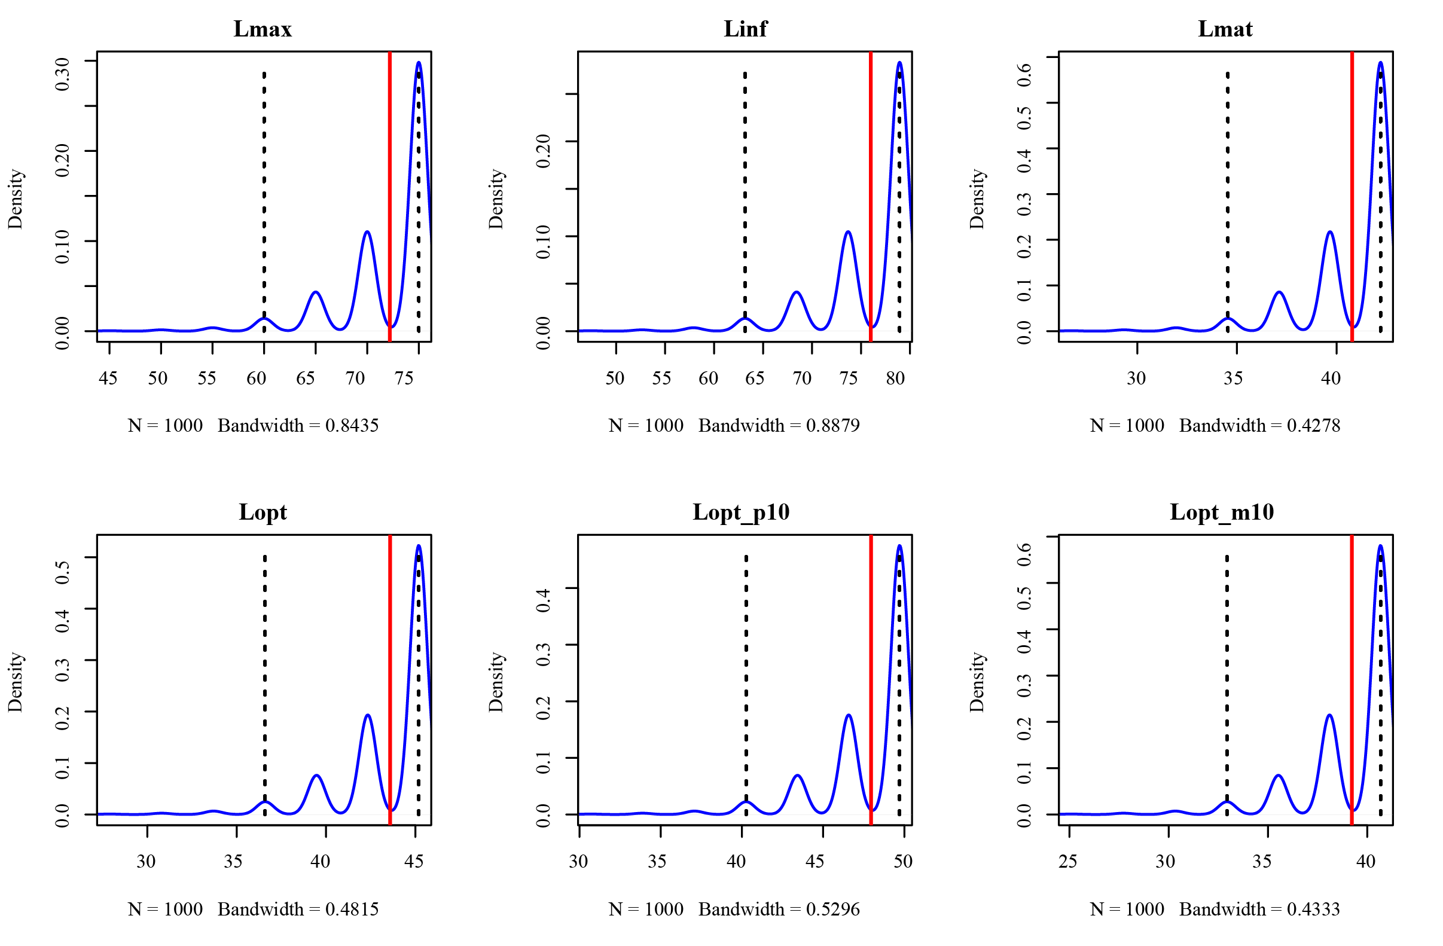

Alternative Summary Statistics
Since skewed distributions may make traditional measures (like mean and median) less informative, consider reporting additional statistics such as the mode or the 25th and 75th percentiles separately. For example, the mode might provide insight into where most resampled values concentrate.

Possible Data Transformation
If interpreting these values in a more normally distributed form is essential, you could try transforming the data, such as by applying a log transformation, although this depends on whether the parameters can be meaningfully log-transformed.
Consideration: This transformation might help normalize the skew but is only advisable if it makes sense given the biological interpretation of these parameters.
In summary, your data has a clear positive skew, likely contributing to the unusual boxplot median positions. This is a valid observation and could be explained in any scientific communication regarding your results.

How can I interpret these distribution of biological and methodological implications
To interpret these distributions in terms of biological and methodological implications, let's break down both the biological and statistical context:

1. Biological Implications:
Multimodality: The presence of multiple peaks (modes) in the distributions could indicate the existence of subgroups within the population, such as different cohorts or growth phases. For instance, certain lengths may correspond to common sizes for age classes or life stages. This highlights natural variability in growth patterns and could reflect the diversity within the population, possibly due to environmental factors, genetics, or resource availability.
Skewness: A skewed distribution might suggest an unequal representation of different life stages. For example, right-skewed distributions (with a longer tail on the right) imply that there are more individuals at smaller sizes, while fewer individuals reach larger sizes. This could be biologically relevant if it reflects survival rates, size-dependent mortality, or other ecological pressures that impact larger or smaller fish differently.

2. Methodological Implications:
Challenges in Parameter Estimation: The skewness and multimodality can complicate fitting models that assume normality or unimodal distributions. When estimating parameters like growth rates or asymptotic length (Linf), these distributional shapes may introduce biases if traditional statistical methods assume symmetric or unimodal data.
Need for Robust Statistical Methods: This complexity suggests that standard approaches to estimating life history parameters may need to be adjusted. For example, you might need to use resampling-based methods, robust statistical techniques, or Bayesian approaches to accommodate the skewness and multimodality. These methods are better equipped to handle the observed variability without imposing overly restrictive assumptions on the data.
Increased Uncertainty: Given the distribution shapes, your estimates for parameters like maximum length (Lmax) and optimal length (Lopt) may have larger uncertainties. This is not necessarily a drawback; instead, it reflects the natural complexity of the biological system. Emphasizing this in your analysis could underscore the importance of capturing a wide range of life history traits when making ecological or conservation decisions.

Summary
The skewed and multimodal distributions indicate a complex biological population structure that requires flexible statistical methods for accurate parameter estimation. Recognizing this complexity provides a more nuanced understanding of fish life history, which could inform more precise management practices or conservation efforts. Emphasizing both the biological diversity and the methodological care taken to account for this in your study could strengthen the case for the relevance and reliability of your approach.

